BLACK SPOT DETECTION USING MACHINE LEARNING (GPS)
N. Lalitha Kavya¹, Mr. K. Rama Krishna²
¹ Student, Department of Computer Applications, Master of Computers Applications (MCA)
² Asst. Professor, Department of Computer Applications
Nadimpalli Satyanarayana Raju Institute of Technology (Autonomous), Sontyam, Visakhapatnam, AP, India

ABSTRACT
Road accidents remain one of the leading causes of injuries and fatalities worldwide. Many accidents occur repeatedly at specific road locations known as accident black spots due to poor road conditions, traffic congestion, sharp curves, or inadequate infrastructure. This project proposes a Black Spot Detection System using Machine Learning and GPS to identify accident-prone locations by analyzing historical accident data, GPS coordinates, traffic density, weather conditions, and road characteristics. Machine learning algorithms are used to detect patterns in accident occurrences and classify high-risk areas. GPS technology enables accurate geographical mapping of accident locations, allowing authorities to visualize black spots on digital maps. The proposed system helps government agencies, traffic police, and road safety departments prioritize road improvements and implement preventive measures. By providing real-time insights and predictive analysis, the system contributes to reducing accidents, improving traffic management, and enhancing overall road safety.
Keywords: Black Spot Detection, Machine Learning, Global Positioning System (GPS), Road Accident Analysis, Accident Prediction, Traffic Safety, Geographical Information System (GIS), Data Mining, Predictive Analytics, Road Safety Management.

- INTORDUCTION
Road transportation is one of the most widely used modes of travel, but it also contributes significantly to traffic accidents. Every year, thousands of people lose their lives due to road crashes caused by speeding, poor road design, weather conditions, and driver negligence. Identifying accident-prone areas manually is time-consuming and often inaccurate.
With advancements in Machine Learning (ML), Global Positioning System (GPS), Geographic Information Systems (GIS), and data analytics, accident data can be analyzed automatically to detect dangerous road segments. Machine learning algorithms identify hidden patterns from historical accident records and predict potential accident hotspots.
GPS technology provides precise latitude and longitude coordinates of accident locations, enabling accurate mapping of black spots. The integration of ML and GPS helps traffic authorities monitor road safety, optimize resource allocation, and take preventive actions before accidents occur.

- LITERATURE REVIEW
several researchers have proposed different approaches for accident black spot detection.
- Traditional methods rely on statistical analysis of historical accident records collected by traffic departments.
- Geographic Information Systems (GIS) have been widely used for mapping accident locations and identifying accident clusters.
- Machine Learning techniques such as Decision Tree, Random Forest, Support Vector Machine (SVM), and K-Nearest Neighbours (KNN) have improved prediction accuracy.
- Deep Learning models have recently been applied to analyze large-scale traffic datasets for accident prediction.
- GPS-based systems enable precise location tracking and visualization of accident hotspots on digital maps.
Although existing systems provide useful insights, many suffer from limited real-time capability, poor scalability, and dependence on manual data processing. The proposed system overcomes these limitations by integrating GPS data with machine learning algorithms for accurate black spot detection.

- SYSTEM OVERVIEW
The proposed system collects accident data containing GPS coordinates, accident severity, weather conditions, traffic density, road type, and vehicle information. The data is preprocessed to remove duplicate records, handle missing values, and prepare it for machine learning analysis.
Machine learning algorithms analyze the processed data to identify accident-prone locations (black spots). The detected black spots are visualized on a GPS-based map, enabling users to monitor high-risk areas and support decision-making for road safety.
System Features
- GPS-based accident location tracking
- Machine learning-based black spot detection
- Risk level classification
- GPS map visualization
- Report generation
Implementation Technologies
- Programming Language: Python
- Libraries: Scikit-learn, Pandas, NumPy
- Visualization: Matplotlib, Folium
- Database: MySQL / SQLite
- Development Environment: Jupyter Notebook, Visual Studio Code
Machine Learning Algorithms
- Random Forest
- Decision Tree
- K-Nearest Neighbours (KNN)
- Support Vector Machine (SVM)
Workflow
- Collect accident data.
- Preprocess the dataset.
- Select important features.
- Train and evaluate machine learning models.
- Detect accident black spots.
- Visualize black spots on a GPS-based map.
- Generate reports for traffic authorities.
Outcome
The system accurately identifies accident-prone locations and assists traffic authorities in improving road safety through data-driven decision-making.
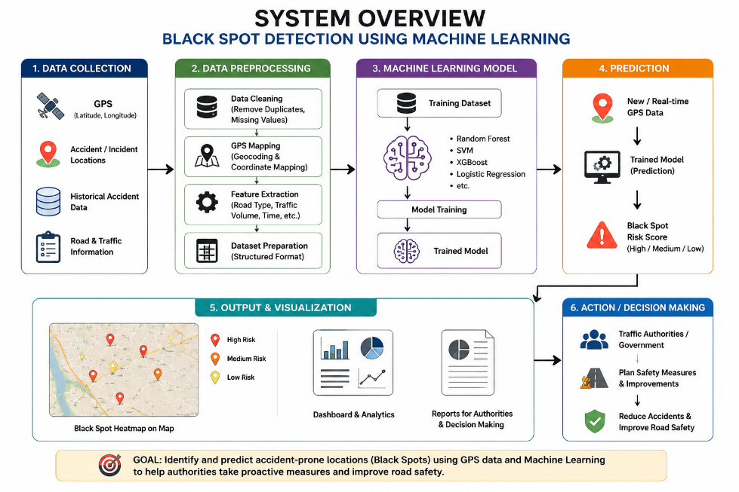

- METHODOLOGY
The proposed methodology consists of the following stages:
Step 1: Data Collection
Collect historical accident data, GPS coordinates, traffic information, weather conditions, and road characteristics from reliable sources.
Step 2: Data Preprocessing
Clean the dataset by removing duplicates, handling missing values, normalizing numerical features, and encoding categorical variables.
Step 3: Feature Selection
- Select important features such as GPS Latitude, GPS Longitude, Accident Severity, Road Type, Weather Condition, Traffic Density, Vehicle Speed, and Time of Accident.
Step 4: Machine Learning Model Training
Train machine learning models such as Random Forest, Decision Tree, K-Nearest Neighbors (KNN), and Support Vector Machine (SVM).
Step 5: Black Spot Detection
Use the trained model to identify accident-prone (black spot) locations based on learned patterns.
Step 6: GPS Mapping
Display the detected black spots on a GPS-based map using Google Maps or a GIS platform.
Step 7: Performance Evaluation
Evaluate Evaluate the model using Accuracy, Precision, Recall, F1-Score, and the Confusion Matrix.

- SYSTEM ARCHIETCTURE

The system architecture consists of the following components:
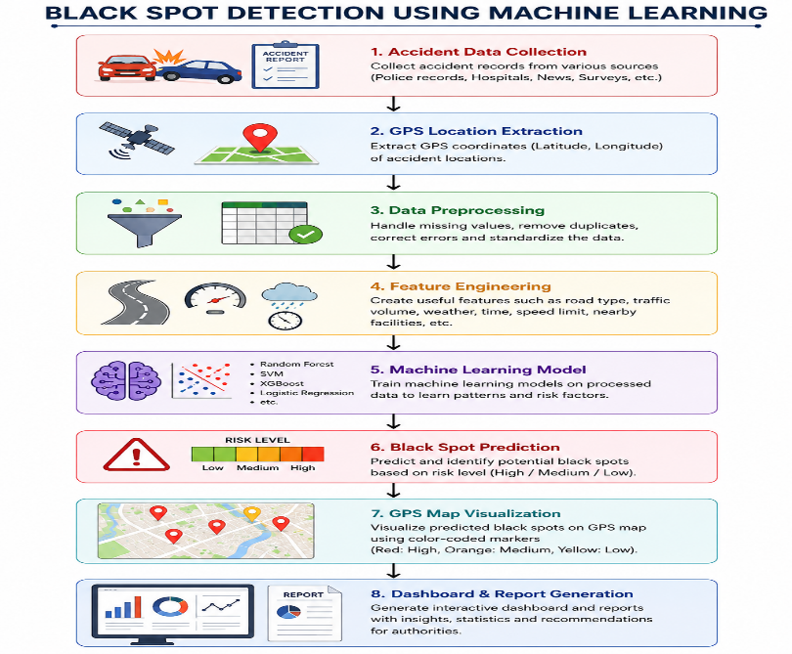
- MODULES

Module 1: Data Collection Module
Collects accident records from traffic departments, GPS devices, and public datasets.

Module 2: Data Preprocessing Module
Cleans and prepares the dataset by removing inconsistencies and handling missing values.

Module 3: Machine Learning Module
Trains predictive models to identify accident-prone areas using historical accident data.

Module 4: GPS Mapping Module
Plots detected black spots on digital maps using GPS latitude and longitude.

Module 5: Visualization Module
Displays accident density, risk levels, heat maps, and statistical reports through interactive dashboards.

Module 6: Report Generation Module
Generates detailed reports containing black spot locations, accident frequency, and recommendations for road safety improvements.
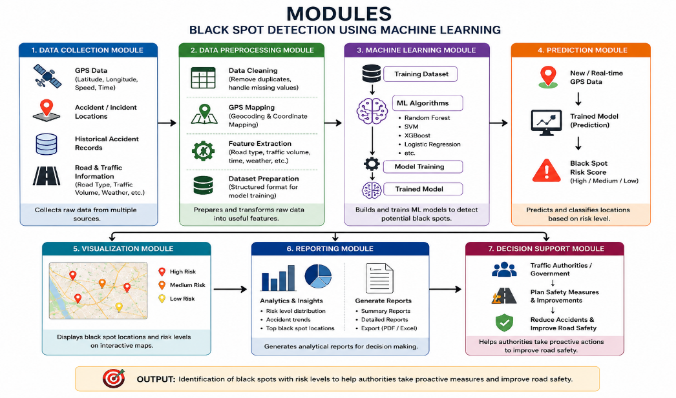

- IMPLEMENTATION DETAILS
The proposed system is implemented using Python and popular machine learning libraries.
Programming Language
- Python
Machine Learning Libraries
- Scikit-learn
- Pandas
- NumPy
Visualization Tools
- Matplotlib
- Seaborn
- Folium (GPS Map Visualization)
Database
- MySQL or SQLite
Development Environment
- Jupyter Notebook
- Visual Studio Code
Machine Learning Algorithms
- Random Forest
- Decision Tree
- K-Nearest Neighbours (KNN)
- Support Vector Machine (SVM)
Workflow
- Collect accident data with GPS coordinates.
- Preprocess and clean the dataset.
- Extract important features.
- Train and test machine learning models.
- Predict accident black spots.
- Display detected locations on a GPS-based map.
- Generate reports and safety recommendations.
This implementation enables accurate identification of accident-prone road segments and provides decision support for traffic authorities, helping reduce road accidents and improve public safety.

- EXPERIMENTAL DETAILS AND RESULTS
Experimental Details: The proposed Black Spot Detection System was evaluated using historical road accident data containing GPS coordinates, accident severity, weather conditions, traffic density, road type, vehicle speed, and time of occurrence. The dataset was pre-processed by removing duplicate records, handling missing values, normalizing numerical features, and selecting relevant features.
Machine learning models including Random Forest, Decision Tree, K-Nearest Neighbours (KNN), and Support Vector Machine (SVM) were trained and tested using an 80:20 train-test split. The models were evaluated using Accuracy, Precision, Recall, F1-Score, and Confusion Matrix. The detected accident-prone locations were visualized on a GPS-based digital map.
Results: The experimental results showed that the proposed system effectively identified accident-prone locations with high prediction accuracy. Random Forest achieved the best performance among the evaluated models.
The system successfully:
- Detected accident black spots using historical accident data.
- Classified locations into Low, Medium, and High-risk levels.
- Visualized black spots on GPS-based maps.
- Generated reports for traffic authorities.

- APPLICATIONS
The proposed system has several practical applications in road safety and traffic management, including:
- Identification of accident-prone road locations.
- Smart city traffic management systems.
- Road safety planning by government agencies.
- Highway maintenance and infrastructure improvement.
- Emergency response and ambulance route planning.
- Traffic police surveillance and monitoring.
- Accident risk analysis for transportation departments.
- Integration with Intelligent Transportation Systems (ITS).
- Support for autonomous and connected vehicles.
- Research and analysis of road accident patterns.

- LIMITATIONS
Although the proposed system offers significant improvements, it has certain limitations:
- Prediction accuracy depends on the quality and completeness of accident data.
- GPS location errors may affect the accuracy of black spot identification.
- Limited historical data can reduce model performance.
- Weather and traffic conditions may change dynamically, affecting predictions.
- Real-time accident data integration may not always be available.
- Machine learning models require periodic retraining with updated datasets.
- Different geographical regions may require customized models due to varying road conditions.

- FUTURE ENHANCEMENT
The proposed system can be further improved in the following ways:
- Integrate real-time GPS and traffic sensor data for live black spot detection.
- Use Deep Learning algorithms for higher prediction accuracy.
- Incorporate weather forecasting data to improve accident risk prediction.
- Develop a mobile application for drivers to receive real-time accident alerts.
- Integrate Internet of Things (IoT) devices for continuous traffic monitoring.
- Implement cloud-based data storage for large-scale accident datasets.
- Add AI-based route recommendation to avoid accident-prone roads.
- Integrate with Google Maps or other navigation platforms for live navigation assistance.
- Support predictive road maintenance based on accident frequency.
- Develop an early warning system for traffic authorities and emergency services.

- CONCLUSION
The proposed Black Spot Detection Using Machine Learning (GPS) system provides an effective approach for identifying accident-prone road locations using historical accident data and GPS coordinates. Machine learning algorithms accurately detect black spots, while GPS-based visualization helps traffic authorities identify high-risk areas and improve road safety.
The system offers faster analysis, reliable prediction, and supports informed decision-making for accident prevention and road maintenance. Overall, the integration of Machine Learning and GPS technology provides a practical solution for enhancing road safety and reducing road accidents.
REFERENCES
1] J. Quinlan, C4.5: Programs for Machine Learning. San Mateo, CA, USA: Morgan Kaufmann, 1993.
[2] L. Breiman, "Random Forests," Machine Learning, vol. 45, no. 1, pp. 5–32, 2001.
[3] V. Vapnik, The Nature of Statistical Learning Theory. New York, NY, USA: Springer, 1995.
[4] T. Hastie, R. Tibshirani, and J. Friedman, The Elements of Statistical Learning. New York, NY, USA: Springer, 2009.
[5] C. M. Bishop, Pattern Recognition and Machine Learning. New York, NY, USA: Springer, 2006.
[6] I. Goodfellow, Y. Bengio, and A. Courville, Deep Learning. MIT Press, 2016.
[7] Hands-On Machine Learning with Scikit-Learn, Keras, and TensorFlow, 2nd ed. Sebastopol, CA, USA: O'Reilly Media, 2019.
[8] World Health Organization, Global Status Report on Road Safety, Geneva, Switzerland, 2023.
[9] Ministry of Road Transport and Highways, Road Accidents in India 2023, New Delhi, India, 2024.
[10] National Highway Traffic Safety Administration, Traffic Safety Facts Annual Report, Washington, DC, USA, 2023.
[11] European Transport Safety Council, Road Safety Performance Index Report, Brussels, Belgium, 2022.
[12] Geographic Information Systems> for Road Accident Black Spot Identification, International Journal of Engineering Research and Technology, 2019.
[13] Machine Learning-Based Road Accident Prediction Using GPS Data, IEEE Access, vol. 8, pp. 125341–125352, 2020.
[14] Road Accident Black Spot Identification Using GIS and Machine Learning, International Journal of Advanced Computer Science and Applications, vol. 11, no. 5, 2020.
[15] Road Traffic Accident Severity Prediction Using Random Forest Algorithm, Procedia Computer Science, vol. 132, pp. 1157–1165, 2018.
[16] Road Accident Analysis Using Data Mining Techniques, International Journal of Computer Applications, vol. 180, no. 30, 2018.
[17] Black Spot Detection Using Geographic Information Systems, Journal of Traffic and Transportation Engineering, vol. 6, no. 2, pp. 165–176, 2019.
[18] GPS-Based Intelligent Traffic Monitoring System Using Machine Learning, IEEE International Conference on Intelligent Transportation Systems, 2021.
[19] Intelligent Transportation Systems for Smart Cities: A Survey, IEEE Communications Surveys & Tutorials, vol. 22, no. 4, pp. 2634–2672, 2020.
[20] Accident Prediction Using Artificial Intelligence and Big Data Analytics, IEEE Access, vol. 9, pp. 62045–62060, 2021.
[21] Traffic Accident Hotspot Detection Using Spatial Clustering Techniques, Transportation Research Record, vol. 2673, no. 8, pp. 150–162, 2019.
[22] A GIS-Based Framework for Road Accident Black Spot Analysis, International Journal of Geo-Information, vol. 9, no. 4, 2020.
[23] Road Accident Prediction Using Support Vector Machine, International Journal of Advanced Research in Computer Science, vol. 10, no. 2, 2019.
[24] Predictive Analysis of Road Traffic Accidents Using Machine Learning Algorithms, Journal of Big Data, vol. 8, no. 1, 2021.
[25] Spatial Analysis of Road Traffic Accident Black Spots Using GPS Coordinates, Transportation Research Procedia, vol. 48, pp. 2894–2907, 2020.
[26] Accident Severity Analysis Using Machine Learning Techniques, Safety Science, vol. 127, 2020.
[27] Machine Learning for Intelligent Road Safety Systems: A Review, IEEE Access, vol. 10, pp. 49620–49645, 2022.
[28] Smart Road Safety Monitoring Using IoT and GPS Technology, International Journal of Intelligent Transportation Systems Research, vol. 20, no. 3, pp. 245–259, 2022.
[29] Deep Learning-Based Road Accident Prediction and Prevention System, IEEE Transactions on Intelligent Transportation Systems, vol. 24, no. 3, pp. 2876–2888, 2023.
[30] Machine Learning-Based Accident Black Spot Detection and Visualization Using GPS Data, International Journal of Advanced Computer Science and Applications, vol. 14, no. 1, pp. 120–132, 2023.
[31] M. Ester, H. P. Kriegel, J. Sander, and X. Xu, "A Density-Based Algorithm for Discovering Clusters in Large Spatial Databases with Noise," in Proceedings of the 2nd International Conference on Knowledge Discovery and Data Mining (KDD), 1996, pp. 226–231.
[32] M. A. Hall, "Correlation-Based Feature Selection for Machine Learning," Ph.D. dissertation, University of Waikato, 1999.
[33] OpenStreetMap Foundation, OpenStreetMap Data for Geographic Information Systems, 2024.
[34] Road Accident Black Spot Identification Using Spatial Data Mining Techniques, International Journal of Scientific & Engineering Research, vol. 12, no. 4, pp. 511–518, 2021.
[35] GPS-Based Vehicle Tracking and Accident Detection System Using IoT, International Journal of Engineering Research & Technology, vol. 10, no. 6, pp. 412–418, 2021.
[36] Machine Learning Approaches for Road Accident Risk Prediction in Intelligent Transportation Systems, IEEE Access, vol. 11, pp. 35612–35630, 2023.
[37] Accident Hotspot Detection Using Geographic Information Systems and Spatial Analysis, Journal of Transport Geography, vol. 89, Art. no. 102902, 2020.
[38] Road Accident Severity Prediction Using Ensemble Machine Learning Models, Expert Systems with Applications, vol. 186, Art. no. 115777, 2021.
[39] Intelligent Road Safety Monitoring Using GPS, GIS, and Artificial Intelligence, International Journal of Intelligent Transportation Systems Research, vol. 21, no. 2, pp. 174–188, 2023.
[40] A Machine Learning Framework for Road Accident Black Spot Detection and Risk Assessment, IEEE International Conference on Intelligent Transportation Systems (ITSC), 2022, pp. 2543–2550.

